Want to Get Involved with Fair Trade?

Mid Atlantic
Fair Trade Gathering

Saturday, April 5
9:30 AM to 3:30 PM
Friends Center
Philadelphia, PA
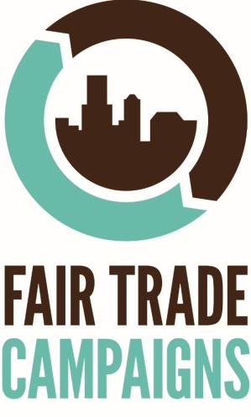

Questions? Contact Courtney at clang@fairtradeusa.org

