Want to Get Involved with Fair Trade?

Mid-West
Fair Trade Gathering

Saturday, April 5
10:00 AM to 4:00 PM
Cardinal Stritch University
Milwaukee, WI
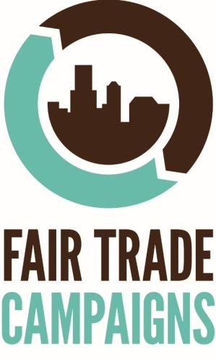

Questions? Contact Parker at ptownley@fairtradeusa.org

