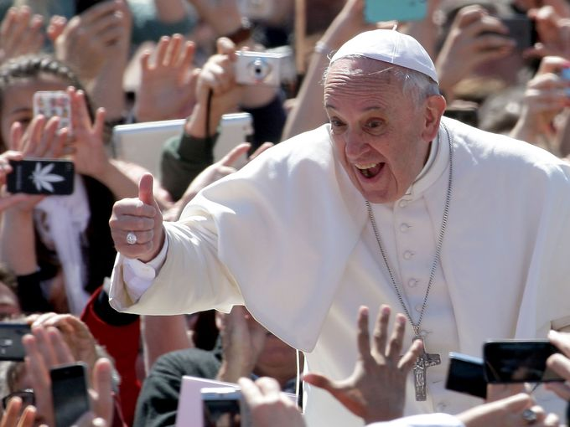

POPE FRANCIS AND FAIR TRADE

“It is a well-known fact that current levels of production are sufficient, yet millions of people are still suffering and dying of starvation. This, dear friends is truly scandalous. A way has to be found to enable everyone to benefit from the fruits of the earth, and not simply to close the gap between the affluent and those who must be satisfied with the crumbs falling from the table, but above all to satisfy the demands of justice, fairness and respect for every human being.” (6/20/13)

“We must say “we want a just system! A system that enables everyone to get on”. We must say: “we don’t want this globalized economic system which does us so much harm!”. Men and women must be at the center as God desires, and not money!” (9/22/13)

