REMEMBER: USE #FTCampaigns on every single related post—this is how we will track success of the campaign, and determine winners

REMEMBER: Follow and tag Fair Trade Campaigns across channels to help us find and promote your posts: Facebook, Instagram, Twitter, Pinterest

REMEMBER: Attach the respective photo to each post—let Fair Trade Campaigns know if you need images sent separately

Fair Trade Campaigns will post everything to Facebook, Twitter, and Instagram to increase reach—we recommend you do the same!

Here are some sample posts for Facebook and Twitter that you can adapt across channels:
POST #1
Facebook:
WIN a trip to Mexico with @FairTradeCampaigns! http://bit.ly/FairTradePhotofest
Enter NOW: 1.) Snap a photo of your favorite Fair Trade product 2.) Post on social media using #FTCampaigns 3.) Get friends and family to vote for your photo

Twitter:
#Win a trip to #Mexico - Post a pic with your favorite #FairTrade product using #FTCampaigns! http://bit.ly/FairTradePhotofest
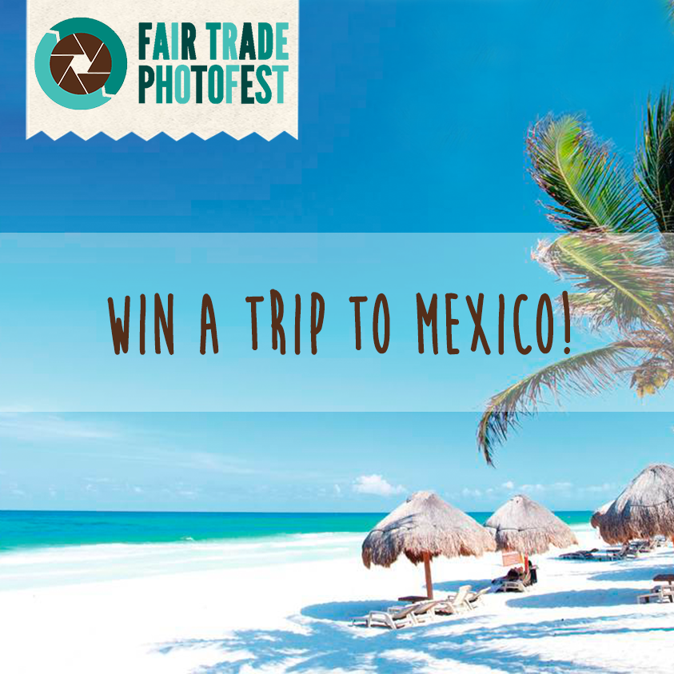
POST #2
Facebook:
WIN a box full of #FairTrade goodies like these comfy @PACT sccks!! http://bit.ly/FairTradePhotofest

Enter NOW: 1.) Snap a photo of your favorite Fair Trade product 2.) Post on social media using #FTCampaigns 3.) Get friends and family to vote for your photo
Twitter:
#WIN: Snap photo w/ your favorite #FairTrade product, tag #FTCampaigns & this could be yours! http://bit.ly/FairTradePhotofest

POST #3
Facebook:
WIN a trip to Mexico with @FairTradeCampaigns! http://bit.ly/FairTradePhotofest
Enter NOW: 1.) Snap a photo of your favorite Fair Trade product 2.) Post on social media using #FTCampaigns 3.) Get friends and family to vote for your photo

Twitter:
#Win a trip to #Mexico: Post a pic with your favorite #FairTrade product using #FTCampaigns! http://bit.ly/FairTradePhotofest

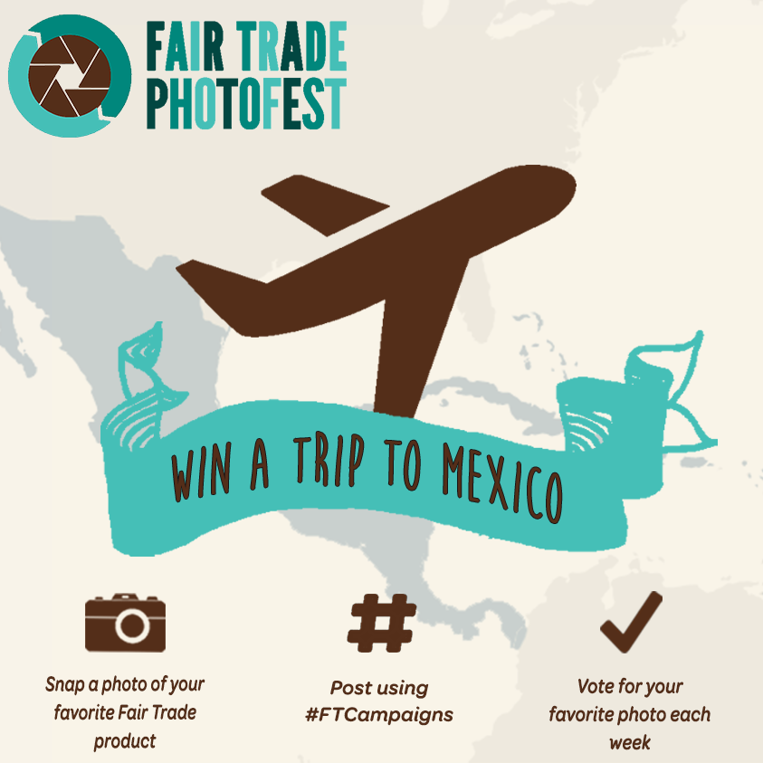

EXTRA TWEETS:
#Win a trip to #Mexico: Post pic with your favorite #FairTrade product using #FTCampaigns! http://bit.ly/FairTradePhotofest

Need a vacation? How about #Mexico? Post pic with #FairTrade product using #FTCampaigns for your chance to #win! http://bit.ly/FairTradePhotofest

Travel to #Mexico with @FTCampaigns! Post pic with #FairTrade product using #FTCampaigns for your chance to win! http://bit.ly/FairTradePhotofest

Want to #win a basket full of #FairTrade goodies?! Post pic with FairTrade product & tag #FTCampaings! #giveaway http://bit.ly/FairTradePhotofest

Meet #FairTrade #Farmers & #Artisans in #Mexico - Check out this photo contest by #FTCampaigns: http://bit.ly/FairTradePhotofest #FTCampaigns

NEWSLETTER BLURB:
In honor of Fair Trade Month, Fair Trade Campaigns will be hosting a photo contest that showcases America's love for Fair Trade products!
The 2015 Fair Trade Photofest begins October 1st and runs through October 31st.
To enter the contest, post a photo of a Fair Trade product on Facebook, Twitter or Instagram using the hashtag #FTCampaigns.
Win $150 Prize Pack! Each of the first three weeks of October will have a theme, starting with “Fair Trade in Action!” The photo with the most votes each week wins a Fair Trade Prize Pack full of goodies and gift cards!
Win a Trip to Mexico! During the fourth week, new entries, plus the top 3 photos from week 1 through 3 will be voted on for the best overall photo. The top two winners of “Best Overall Photo” will win a trip to Mexico.
For contest rules and entry follow this link: http://bit.ly/FairTradePhotofest
OTHER ASSETS:
