POPE FRANCIS & FAIR TRADE CONGREGATIONS

Pope Francis used his annual World Peace Day Message to condemn the modern day slavery of 11 million men, women and children and urge us to action.
Speaking to consumers “… we are tempted to select items which may well have been produced by exploiting others. Some of us, out of indifference, or financial reason or because we are caught up in our daily concerns, close our eyes to this. Others, however, decide to do something about it.”
“I urgently appeal to all men and women of good will … not to become accomplices to this evil, not to turn away from the sufferings of our brothers and sisters.”
We know that God will ask each of us: “What did you do for your brother? (cf. Gen 4:9-10). The globalization of indifference … requires all of us to forge a new worldwide solidarity and fraternity capable of giving them new hope and helping them to advance…”

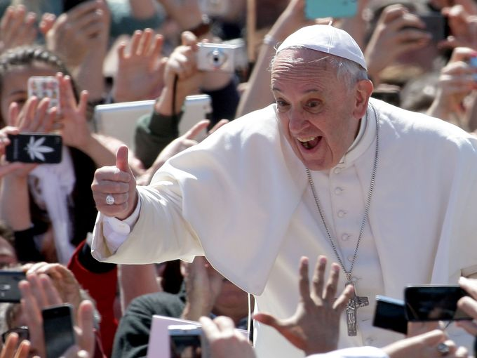
Fair Trade offers a powerful response to Francis’ challenge to “do something“ about this suffering, to shun indifference and avoid becoming an accomplice. Fair Trade products are free from exploitation, as certified by independent inspectors. And the Fair Trade logo on a package assures just wages and safe working conditions, combating poverty. Several parishes in greater Los Angeles have answered Francis’ call. They have incorporated Fair Trade into parish life, by educating on how one can respond to global injustice when shopping and by using Fair Trade products in parish activities whenever possible. They have become Fair Trade Congregations.
The path to recognition and public witness as a Fair Trade Congregation is not difficult, does not involve a multitude of meetings nor impose new burdens on parish staff. It simply takes a prayerful decision to join in forging “a new worldwide solidarity and fraternity capable of giving them new hope and helpin them to advance.”
ABOUT FAIR TRADE

Fair Trade is a sustainable business model that incorporates principles that respect small producers and protect the environment. By contrast, “business-as-usual”, in a quest to maximize profit at any cost, often engages in practices that exploit workers and the planet. Fair Trade defends the dignity of workers, combats poverty and preserves nature. Fair Trade gives consumers an opportunity to live in solidarity with farmers and small producers throughout the world.

FAIR TRADE PRINCIPLES

- Fair prices and wages for farmers and workers.
- Safe working and living conditions
- Environmentally sustainable practices
- Investments in the local community
- Gender equality
- No forced of abusive labor (child or adult)

When a product meets these standards, as verified by independent inspections, a Fair Trade Certified logo is placed on the package. Over 1,000 products now carry a Fair Trade logo.
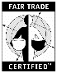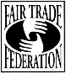

YOUR GUARENTEE THAT IT’S FAIR TRADE
Fair Trade is endorsed as a means for sustainable development (it’s not a hand out) by Catholic Relief Services, the US Conference of Catholic Bishops and by all major religions in the United States.
People of good will have made Fair Trade the fastest growing segment of the US economy.

More information: crsfairtrade.org
fairtradeusa.org
fairtradeamerica.org

