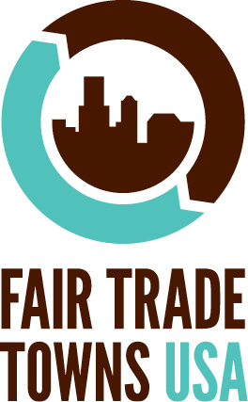
[CAMPAIGN NAME]
Petition to Make [TOWN] a Fair Trade Town

[CAMPAIGN NAME] brings together community groups, businesses, and individuals to raise awareness of and promote Fair Trade in [TOWN]. We are currently working to make [TOWN] a Fair Trade Town by meeting five criteria: forming a steering committee; conducting outreach to area retailers; engaging the community; gaining media attention, and passing a Fair Trade resolution.
- Yes, I support [campaign name] in their campaign to make [TOWN] a Fair Trade Town! I believe that Fair trade enhances the livelihood opportunities of producer & artisan communities in the developing world and is integral to a sustainable global marketplace.
I also want to (please check):
Signature Print Email  Address Phone | Join Steering Committee | Join Email List | Volunteer at Events

Signature Print Email  Address Phone | Join Steering Committee | Join Email List | Volunteer at Events

