**FAIR TRADE HIGH SCHOOL Name:**

**BUYER’S GUIDE Date:**

C:\Users\PCR\AppData\Local\Microsoft\Windows\Temporary Internet Files\Content.IE5\D6K25X15\MC900060029[1].wmf

**Design a Buyer’s Guide**

For this activity, please **submit an entry for a student’s guide to buying FAIR TRADE**. Your submission should be produced so it will be **camera-ready**. Include all relevant information. If the product is available from a **local FAIR TRADE merchant**, be sure to include the store’s location and hours. If the product is **only available online**, don’t forget the web address. Keep in mind **your buyer’s guide is for high school students** – include items they would want to buy. Type your name, along with the phrase “RECOMMENDED BY,” on the bottom of your entry.

The example below was made with MS Office and features information from a website. Before you begin your own advertisement, list four qualities that make it effective:

1.

2.

3.

4.

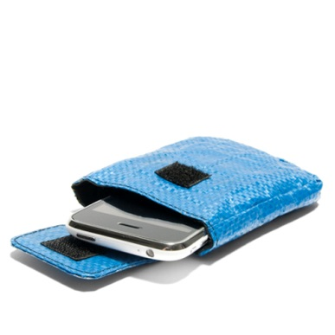

**ARTISAN:** [Artisans Association of Cambodia](http://www.globalgoodspartners.org/template/producer.cfm?cbo=11)

**IMPACT:**  A proud member of the Fair Trade Federation and Green America, we work with women artisans who would not otherwise have access to export markets, offering economic opportunity for them, their families, and their communities.

**ECO-FRIENDLY iPHONE CASE**

Each case is crafted with care by Cambodian producers from **recycled rice bags**. These artisans come from some of the most marginalized groups in Cambodia; these **simple yet fun** iPhone cases are a great way to **promote eco-friendly development** in their communities.

* **Material: Rice bag Size: 4½”L x 3¼” W x 5/8"D Fully lined with a Velcro flap closure**

It’s 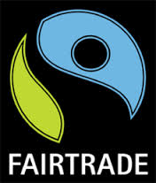 and just $8 at!

**VISIT** <http://www.globalgoodspartners.org/cart/Details.cfm?ProdID=537&category=0> TO ORDER.

RECOMMENDED BY: Jonathan Kopper .