2014 MLK Education Station for Grades 3-8

Source: Media-Providence Friends School
Time Required: 20-25 minutes
# of Partcipants: Works best with small groups of 10-15 students, we did mixed age
Materials: Human Bingo Cards, 1 per student
Pencils
World Map
Mini sticky-note tabs
MLK Quote
Grocery bag & foods (see suggested list below)
Fair Trade chocolate mini (Divine, Equal Exchange)
Alternate small food item (e.g. Smarties) for children with allergies
MPFS_MLK Day_Grades 3-8_Educating Ourselves.ppt

Objective: Activate students’ knowledge about our connections with each other and everyone around the world. Associate this notion with the idea that our choices impact upon others, honing in on our food choices, leading to making the choice to purchase Fair Trade items. Map countries of origin for various foods and identify common characteristics of Fairly Traded food staples. Conclude with mindfulness exercise to encourage reflection.

1. Hand out Human Bingo Game Cards.

“Welcome! We’re going to start with a game – see how many of the bingo squares you can fill in by talking to others in the next 5 minutes. Try to find a different person for each square. It’s not a race, and if you haven’t been able to fill all your squares in 5 minutes, that’s okay.”

Start timers.
Give warning at one minute left mark.

2. Share & map some Bingo results using questions that speak to other countries for 2 minutes by prompting:

“What were some of the responses to the ‘Who ate food from another country and which country was it?’ “

Next, “How about: ‘What other countries had people visited?’ or ‘Who had clothing on from another country?’ “

3. Mark each country indicated with a sticker on world map on Smartboard – aiming for 7 or so distinct stickers in a variety of countries/continents.

4. Summarize:

“Look at all the connections we have with the rest of the world, just in this room alone”

5. Reference MLK Quote (below) about interconnectedness:

“Think back to this morning when the 7th Grade read the quote from Dr. King about interconnectedness. What do you remember about the quote?”

6. Allow for 1 minute of responses, then:

“So, we’re all connected. That means our choices affect other people. We can choose to make a better world.”

7. “There were a number of foods mentioned in Dr. King’s quote. We can make a big difference through our food choices. Let’s list some of the considerations people might use when food shopping. For example, people might choose to buy food based on its price… what are some other considerations?”

8. Allow for 30-60 seconds of responses, and then if not given, quickly provide these additional:

- Where it was produced and processed
- What impact it has on the environment/packaging
- Its nutritional value
- Whether it is organic
- How the workers who grew it/made it were treated

9. Shopping Bag Activity – pass out items from shopping bag, one per person.

“Let’s look at these items that might be found in an average grocery bag. I’d like you to carefully and gently examine yours to find out where it came from – its country of origin, NOT the location of its distributor. Once you’ve determined where it came from, carefully put it on its country of origin on the map on the floor. If you’re not sure, ask me for help.”

Allow 1 minute, and then start helping any who can’t figure out, wrapping up in another 30 seconds.

10. “What do you notice about the items that AREN’T products of the United States?”

Allow for 30 seconds of answers, and if not elicited, note “So, many ‘staple products’ seem to come from tropical, developing countries – those where poverty is more common, where people might not have access to safe drinking water, medicine, or education like we do. Also, these all have the Fair Trade logo.”

11. Show logo/marks

12. “So, what does Fair Trade mean to you?”

Allow 1 minute and If not brought up, note that “Fair Trade:

- ensures farmers earn a living wage so they can meet their families’ needs
- makes sure the environment is cared for
- improves communities with schools, wells, and health care
- ensures good working conditions

13. “We’re fortunate to be located in Media, America’s First Fair Trade Town where there’s a lot of local support already for Fair Trade and lots of places where you can ask for and buy certified Fair Trade items.
.
“The Fair Trade Schools movement began in the UK in 2007 with the goal of educating kids like you, who are tomorrow’s consumers. (point to UK on Smartboard map)

“Today, 1,000 schools in the UK have been Fair Trade certified, with another 4,000 working towards certification.

“Fair Trade is consistent with the values MPFS teaches and we can all be proud to be among first 13 schools in the U.S. to become Fair Trade certified”.

14. Pair & Share. Hand out one Fair Trade Chocolate mini asking everyone to hold onto it – not to unwrap or eat it until instructed.

“This is a Fair Trade chocolate. Don’t unwrap or eat it until I tell you to… Okay, now that everyone has a piece, I want you each to turn to the person next to you and describe one thing you can do to promote Fair Trade. After you’ve done that, unwrap your chocolate and slowly and mindfully enjoy the taste. Let it melt in your mouth and as it does, think about how we’re all connected, about how our choices impact upon others, and about the lives you are making a difference in when you enjoy Fairly Traded foods.”

Human Bingo Find Someone Who…
Has visited another country.  Person:________________  Country:_______________ | Plays a musical instrument.  Person:________________  Instrument:______________ | Is left-handed.  Person:________________
Can say “Hello” in more than 2 languages.  Person:________________  Language 1: English  Language 2: Spanish  Language 3:____________ | Is wearing clothing from another country.  Person:________________  Country:_______________ | Has 2 or more pets.  Person:________________  Pet 1:_________________  Pet 2:_________________
Has more than 2 siblings.  Person:________________  # of Siblings:___________ | Shares your birthday month.  Person:________________  Month:_______________ | Recently ate cuisine of/ food from another country.  Person:________________  Country:_______________

Human Bingo Find Someone Who…
Has visited another country.  Person:________________  Country:_______________ | Plays sport outside of school.  Person:________________  Sport:______________ | Has the same favorite color.  Person:________________  Color:_________________
Can say “Hello” in more than 2 languages.  Person:________________  Language 1: English  Language 2: Spanish  Language 3:____________ | Is wearing clothing from another country.  Person:________________  Country:_______________ | Walks to school.  Person:________________
Has 2 or more siblings.  Person:________________  # of Siblings:___________ | Shares your eye color.  Person:________________  Color:_______________ | Recently ate cuisine of/food from another country.  Person:________________  Country:_______________

Human Bingo Find Someone Who…
Has visited another country.  Person:________________  Country:_______________ | Also likes your favorite game.  Person:________________  Game:_________________ | Has lived in another state.  Person:________________
Can say “Hello” in more than 2 languages.  Person:________________  Language 1: English  Language 2: Spanish  Language 3:____________ | Is wearing clothing from another country.  Person:________________  Country:_______________ | Has an allergy.  Person:________________
Has 2 or more siblings.  Person:________________  # of Siblings:___________ | Was born in the same year.  Person:________________  Year:_______________ | Recently ate cuisine of/food from another country.  Person:________________  Country:_______________

Human Bingo Find Someone Who…
Has visited another country.  Person:________________  Country:_______________ | Enjoys arts or crafts.  Person:________________ | Has the same favorite color.  Person:________________  Color:_________________
Can say “Hello” in more than 2 languages.  Person:________________  Language 1: English  Language 2: Spanish  Language 3:____________ | Is wearing clothing from another country.  Person:________________  Country:_______________ | Lives with 2 or more different animals.  Person:________________  Animal 1:_______________  Animal 2:_______________
Has more than 2 siblings.  Person:________________  # of Siblings:___________ | Shares your hair color.  Person:________________  Color:_______________ | Recently ate cuisine of/food from another country.  Person:________________  Country:_______________
(Read by 7th Graders in All-School Meeting prior to start of activities)

“We are all caught in an inescapable network of mutuality, tied into a single garment of destiny. Whatever affects one directly, affects all indirectly. Did you ever stop to think that you can’t leave for your job [school] in the morning without being dependent on most of the world?

“You get up in the morning and go to the bathroom and reach over for the sponge, and that’s handed to you by a Pacific Islander. You reach for a bar of soap, and that’s given to you by the hands of a Frenchman. And then you go to the kitchen to drink your coffee for the morning, and that’s poured into your cup by a South American. Or maybe you want tea; that’s poured for you by an Asian. Or maybe you’re desirous of having cocoa, and that’s poured into your cup by a West African. And then you reach over for your toast, and that’s given to you at the hands of an English-speaking farmer, not to mention the baker.

“Before you finish your breakfast in the morning, you’ve depended upon more than half the world. This is the way our universe is structured, this is its interrelated quality. We aren’t going to have peace on Earth until we recognize this basic fact of the interrelated structure of reality.”

Dr. Martin Luther King, Jr.

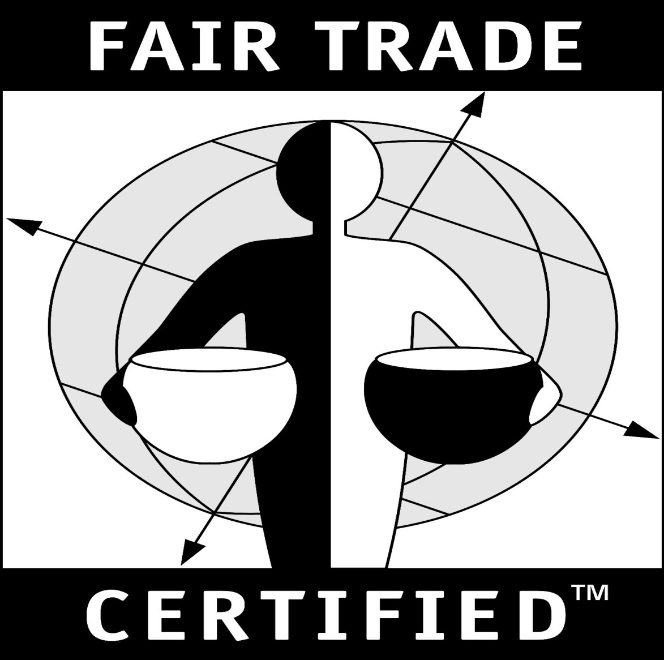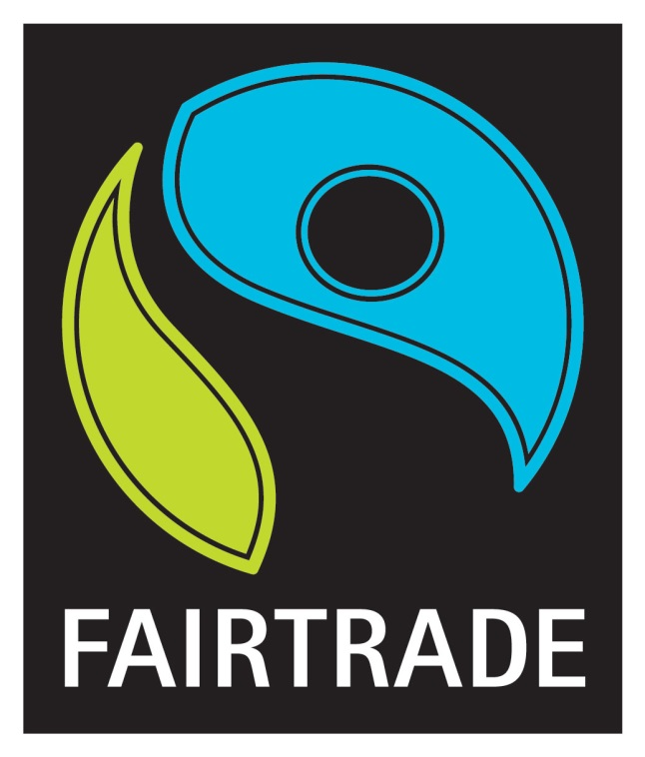

THE WORLD IN MY SHOPPING BAG

Grocery bag with 12 items:

- egg carton (local)
- healthy cereal box (domestic)
- an apple (domestic)
- a seasonal, fresh, vegetable like potato or greens (local)
- Mochi box (domestic)
- Fair Trade coffee (Uganda or Ethiopia)
- Fair Trade sugar (Philippines)
- Fair Trade rice (Thailand)
- Fair Trade chocolate (Peru)
- Fair Trade agave nectar (Mexico)
- Fair Trade tea (Sri Lanka)
- Fair Trade banana (Ecuado or Costa Rica)

*Be sure the packaging of the Fair Trade items feature one of the Fair Trade logos and indicate the country or origin somewhere!

